Cameron Mathews

August 24, 2021

IT FDN 110 A Su 21

Assignment08

<https://github.com/cmathews10/IntroToProg-Python-Mod08>

<https://cmathews10.github.io/IntroToProg-Python-Mod08/>

# Modifying an Existing Script to Work with Classes

### Introduction

The following document outlines the steps taken to modify and update a Python script to work with classes.

### Process

1. Write the script in PyCharm.
   1. I struggled with the data formatting that occurs when upon the initial load/read of the file data.
   2. I had a persistent issue with adding a new item to the list caused by the missing return in the if statement.
   3. I could not identify any user errors that would not be addressed by the current code.
2. Run the script in PyCharm (see pdf attachments).
3. Run the script in the Command Prompt window (Figure 1).

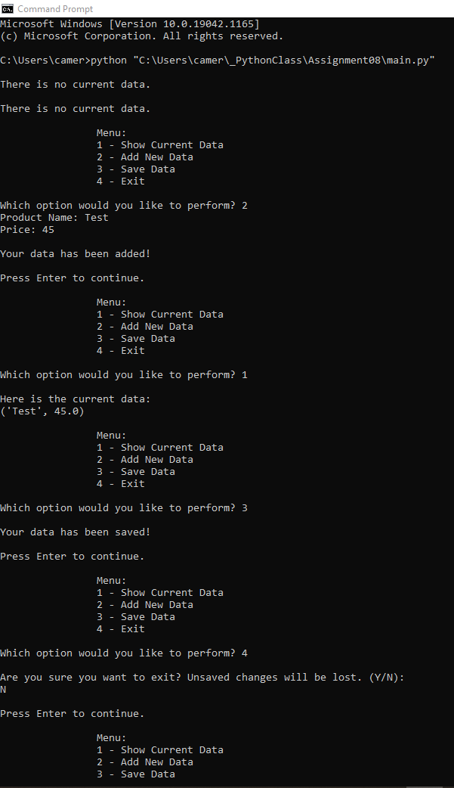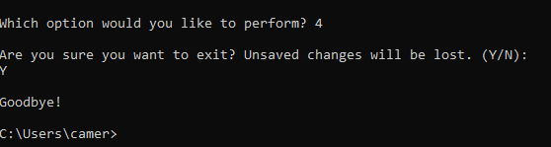

***Figure 1: Example of the script successfully running in the Command Prompt window.***

1. Confirm user input is being saved to the defined file location (Figure 2).

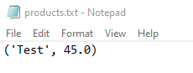

***Figure 2: Image of the text file that updates based on user input.***

### Summary

This document outlined the steps taken to modify and update a Python script to work with classes.